COMM_3 :Food waste management By sustainable production and consumption-preserve the precious

1: anila chowdary sakamuri
cse department
, RMD Engineering college, kavaraipettai
4.yamini mettu
cse department
, RMD Engineering college, kavaraipettai
2:swarna sangana
cse department
, RMD Engineering college, kavaraipettai
5. Mrs. Logesswari
AP/CSE assistant professor ,
RMD Engineering college,
kavaraipettai
3.charitha mandyam
cse department
, RMD Engineering college, kavaraipettai

6. Dr. S. Rekha
Chemistry Associate Professor, S&H Department, RMD Engineering college, kavaraipettai

Abstract— Our planet is under crick strain. The global population push the figure of 9.6 billion by 2050, we need three Earths to sustain current lifestyles for everyone. Each year, an estimated one-third of all food produced – equivalent to 1.3 billion tonnes – ends up rotting in the bins of consumers and retailers, or spoiling due to poor transportation and harvesting practices.
This was developed in 2015, the Sustainable Development Goals (SDG)were a call to change the world that we live in. The UN proposed a method of change that centred on global sustainability targets.
Sustainable consumption and production aims at “doing more and better with less,” increasing net welfare gains from economic activities by reducing resource use, degradation, and pollution, while increasing the quality of life. Sustainable development will be achieved not only by growing our economies, but minimising waste in the process of doing so. Growth that contaminates the environment sets development back.
Sustainable consumption and production is about promoting resource and energy efficiency, sustainable infrastructure, and providing access to basic services, green and decent jobs and a better quality of life for all. Its implementation helps to achieve overall development plans, reduce future economic, environmental and social costs. It involves engaging consumers through awareness-raising and education on sustainable consumption and lifestyles. Overall abstract of this project is to calculate the net rate of production and consumption and at certain place, our project ultimate goal is to preserve the precious food. Through our programme we are able to give a information to all to balance both the consumption and production
Keywords—global goal, sustainable, consumption, production, programme .

Introduction
Responsible production involves the production and consumption of goods and services in an ethical way which involves the minimization of waste and pollution. In the past little thought was given to the way in which resources were used in the production process. The emphasis was on creating the maximum profit from resources available. Today, it is common practice to develop systems for the management of production and other systems. For example British, European and International Standards have created an Environmental Management Standard for companies to comply with as well as ISO 9000 which is an international standard for quality management. By setting up systems to comply with these standards, organisations are able to be accredited as meeting this standard. Other suppliers are then more inclined to do business with these organisations because they have shown that they can produce in a responsible way. Sustainable production and consumption can be defined as production and use of products and services in a manner that is socially beneficial, economically viable and environmentally benign over their whole life cycle. The journal aims to provide a leading platform for publishing high-quality interdisciplinary papers on research and practice in this emerging field. It looks uniquely at the interactions between technology, consumption and policy to help identify more-sustainable solutions for both production and consumption systems. Consumption and production are essential to the global economy. Anthropogenic harm to the environment and human health is almost entirely the result of production and consumption activities. At the same time, food security, poverty alleviation, medicine, infrastructure, welfare and services all depend on productive activities and the wealth they generate.[1]Thus most, if not all, of the SDGs are thus intricately linked with SDG 12. SDG 12 calls for “responsible consumption and production”. It aims at decoupling economic growth from environmental damage and natural resource exploitation. Its eight targets include implementation of the 10-Year Framework of Programmes on SCP, efficient management and use of natural resources, cutting various types of waste, and responsible management of wastes and chemicals. It also calls for adoption of sustainable practices in companies and in public procurement. Increasing population and anthropogenic activities have brought about many environmental problems. The growth of the world population increasing need for water has led to this geological hazard that has affected all continents of the world except Antarctica. The Environment sustains life. Man needs to know the importance of environment and help keep the environment as healthy and productive as much as possible.
APK (Android Package File) is the name given to the installation file of games and programs prepared for devices with Android operating system. Applications are installed on the phone through this file. You can use the downloaded APKs without the need of Google Play Store or other markets

Literature survey
There are few methods for not only enhancing the production but also to conserve the global goal 12 which refers to responsible production and consumption.

Vision on technical development on waste reduction
Being in the 21st century ,we should develop a lot of
Technical things which help us to reduce the production of food waste. applying sensor technology to increase traceability is another technology that could reduce food waste by at least 5% within the supply chain.

Research to find more techniques to increase the production rate
Not only the traditional methods can help the farmers to increase the production rate but also the modern techniques should be able to increase the production rate which cause less wastage in the production

Ensuring sustainable consumption and production.
- First :To develop production patterns in agriculture sector
- Second: To study of consumers behaviour towards sustainable food products.[5]
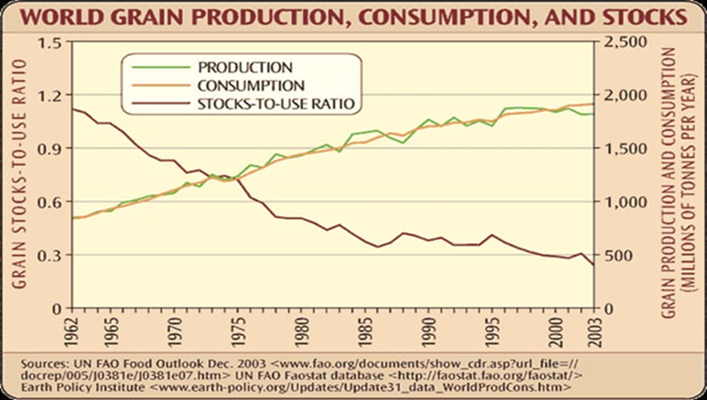
Fig 1:graph representing world grain production, consumption and stocks.

- The graph represents the relation between the production and consumption from year 1962-2003. It shows us the imbalance in the production and consumption.
If this continue we have to face a situation where the people has a lot of money who can’t full fill their hunger.

Methods and implimentations
Many people have done a lot of researches on how to enhance the production of food and also thought how to maintain
The sustainability in production and consumption of food. But now we made a step where we can find the wastage produced in a particular place through which we can maintain the balance in the production and consumption. Through our code we can find the net amount of crop that get wasted or still remained. This will make our goal easy.
Not only the code can help you to reach our goal we have also made an apk which helps you to know more about the production and consumption. through our apk you are able to know about the countries and their production rates not only this you can also know about the latest technology through which you can increase the production rate in ease. We have also recommended some videos in you tube and also include some links of google where you can know more about cultivation and you can also know about recent trends in production and consumption in a sustainable way. And finally we will take a survey to know more about the place and their food availability and also their opinion on the food availability of there area.

CONCLUSION

"preserve the precious "is meant to conserve the most precious thing in this world which is the food.
The consumption rate is increased day by day as the population rises.
The productivity of world food has raised through out last century through technological methods and consumers are feeling incomplete towards food availability all over the world ,both the rich and poor are effected by globalization.
Responsible food consumption may play an important role in food system sustainability.
The paper introduces to the concept of sustainable food consumption and production ,waste management ,and methods to implement production and sustainable food management. A large number of the world population is still consuming too little food even to meet their basic needs. A large section of people in India is facing food insecurity, as they don’t have affordability and accessibility to food even for two times a day.
Population growth and food supply have long been of central concern to governments and to economists. The World Food Economy examines the lessons of the past while assessing 21st century and future challenges, including food shortages, global hunger, and economic inequality.
With the demand for food and the population growing at an unprecedented rate, this project provides students with a timely, relevant, and unique overview of the world food production.

Finally we can say that our code helps you to understand :

1. How much amount of crop is being wasted or how much amount of crop is to be required.
2. How to enhance the production rates by knowing the recent technology .
3. Knowing more about the trending news based on sustainable production and consumption.
4. Different countries and their respective production rates.

Link to download apk :

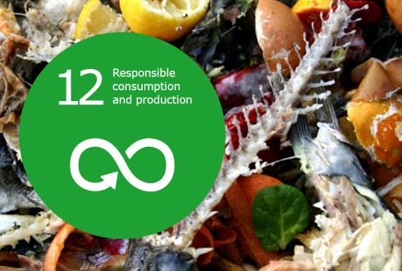

Fig 2: logo of our apk “preserve the precious”

https://my.mobiroller.com//downloadAPK/?apk=1372132873692.apk

References

- 0https://www.un.org/sustainabledevelopment/sustainable-consumption-production/ (to know more about global goals)
- Techniques for the Detection, Identification, and Diagnosis of Agricultural Pathogens and Diseases,Ajay Kumar Gautam PHD,
- Food Waste Management with Technological
Platforms: Evidence from Indian Food Supply Chains
Youthika Chauhan,Kenan-Flagler Business School, University of North Carolina, Chapel Hill, NC 27599, USA;
[4] Consumption and Production Patterns for Agricultural Sustainable Development
Department of Agricultural, Food and Forest Sciences, University of Palermo, Viale delle Scienze, Edificio 4,90128 Palermo, Italy; riccardo.testa@unipa.it
[5] https://www.sciencedirect.com/topics/agricultural-and-biological-sciences/food-crops (to know more about biological sciences)

